METHODOLOGY

This chapter presents the methodology used in developing the Employability Prediction System for the Department of Computer Studies. It discusses the design of the software, system development process, testing, evaluation, data analysis, and implementation plan.

Design of Software, Systems, Product and/or Processes
Figure 2 presents the hierarchical input-process-output diagram of the system.
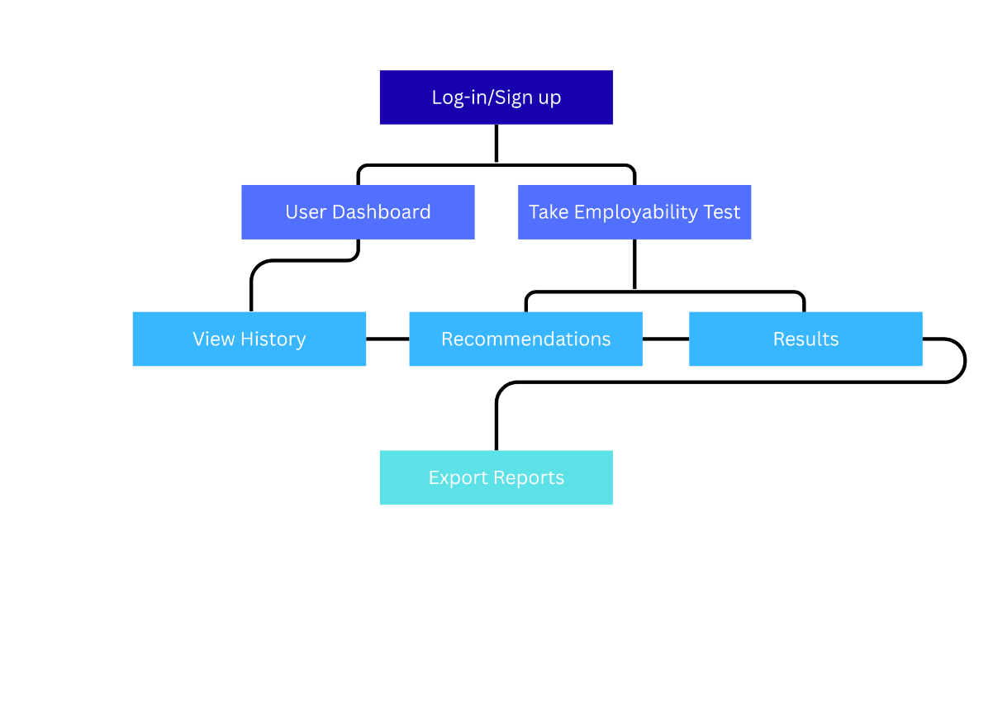
Figure 2. HIPO diagram of the system
Figure 3 shows the use-case diagram of the system.
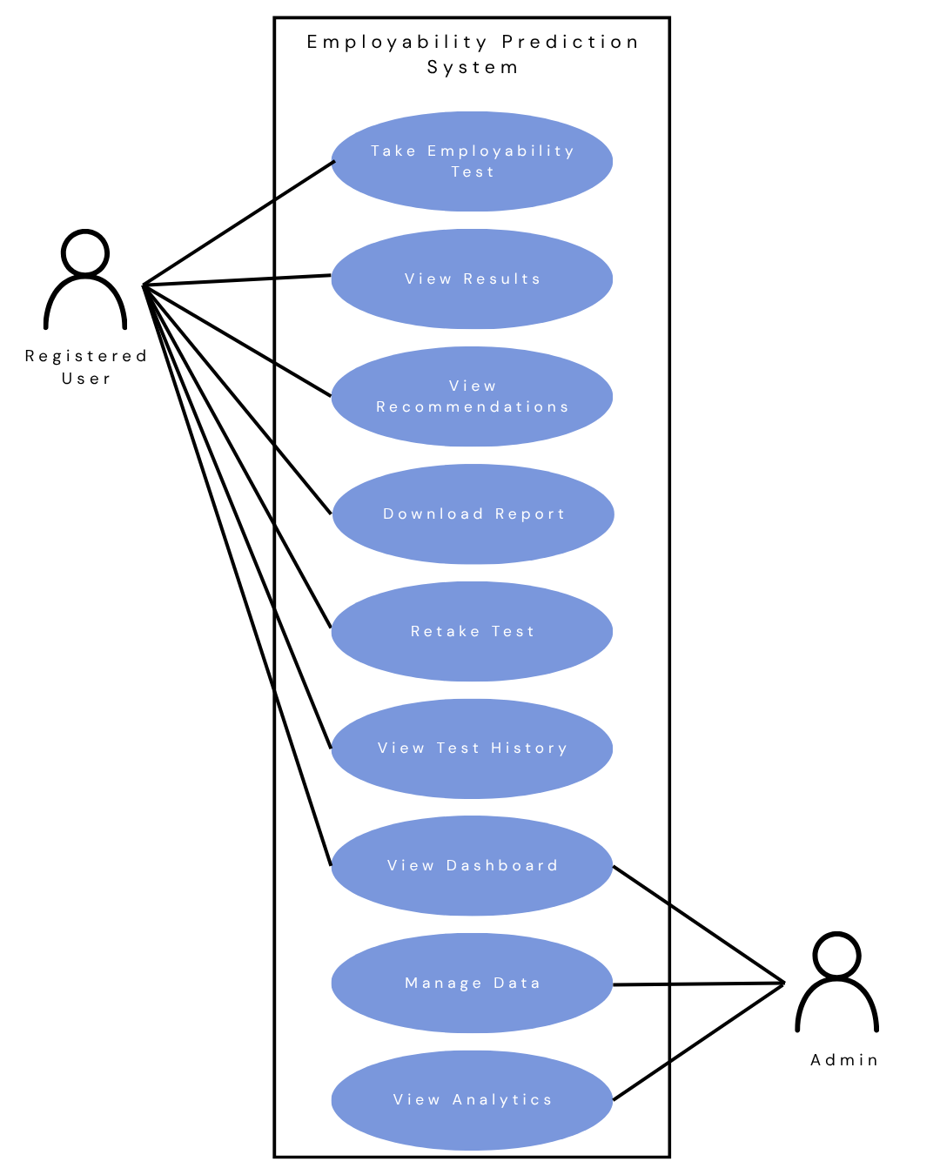
Figure 3. Use-case diagram of the system
Figure 4 shows the graphical user interface design of the system.



Figure 4. Homepage
Figure 4.1 About Page

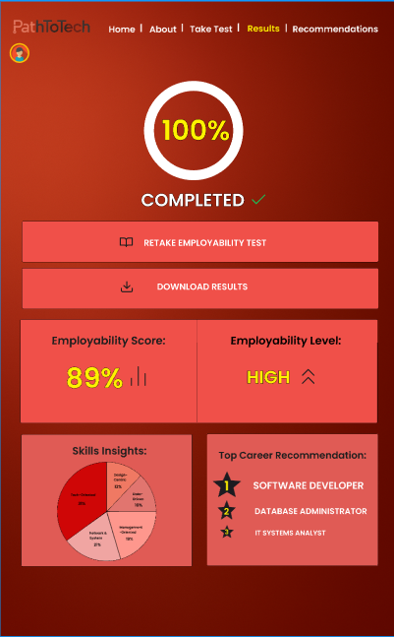

Figure 4.2 Employability Test

Figure 4.3 Results
Figure 4.4 Recommendations
Figure 4.5 User Sidebar

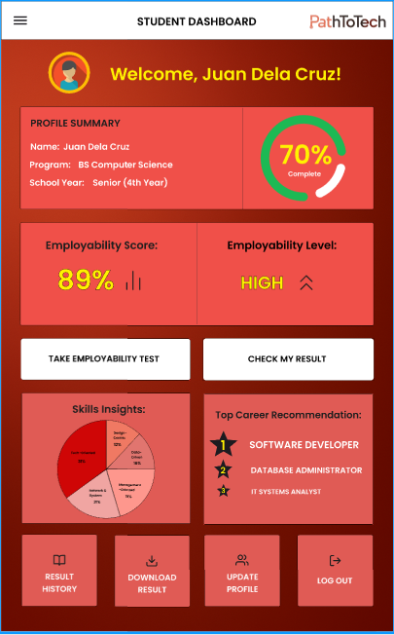
Figure 4.6 User Dashboard

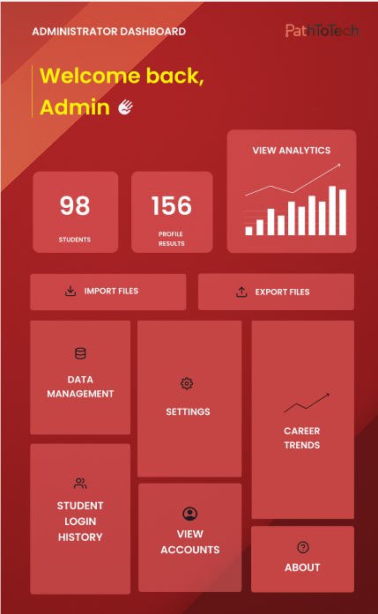
Figure 4.7 Admin Dashboard

Requirement Analysis
The current employability assessment in the Department of Computer Studies relies mainly on academic performance and faculty evaluation, lacking an automated and data-driven approach. The proposed system addresses this gap by integrating survey data, clustering algorithms, and association rule mining to objectively determine employability readiness.
The research will include participants from the Department of Computer Studies, along with faculty advisers. The main focus is on assessing employability, categorizing job qualifications, and generating career recommendations. This study will take place at the Cavite State University – CCAT Campus, specifically in the Computer Studies Department. Data collection and the development of the model are scheduled from October 2025 to July 2026. Training data will be collected from Kaggle, were the dataset has been meticulously gathered from diverse sources, including job portals, career fairs, and online applications, over a specified period. Input data will be collected from admin imports and questionnaire answers from current students. The system will be created using Python for the machine learning components and a web interface developed with React.js and Firebase.
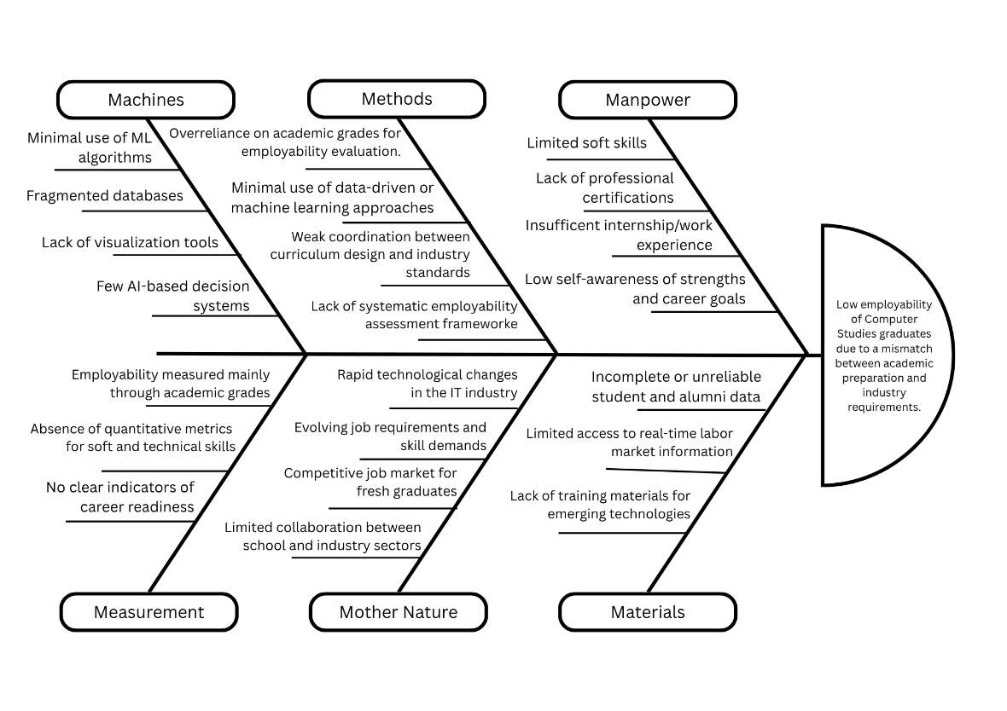
Figure 5 presents a fishbone diagram that shows the operational feasibility of the system.
Figure 5. Fishbone diagram of the system
Table 1 presents the list of technical resources available in the organization that can be used to run the system to be developed.
Table 1. List of technical resources available in the organization
LIST OF RESOURCES AVAILABLE | STATUS
2 Laptops | Working
Printer | Working
Wifi - Internet Connection | Working

Table 2 presents the estimated cost of the system development.
Table 2. Estimated cost of the system
LIST OF EQUIPMENT | COST
Laptops | PhP 45,000.00
Printer | PhP 2,500.00
TOTAL COST | PhP 47,000.00

Requirement Documentation

The proposed system consists of the following modules:

User Interface Module – Displays employability test, results, and

recommendations.

Data Processing Module – Handles data cleaning, normalization, and conversion to numerical features.

Clustering Module – Groups job qualifications using the Gaussian Mixture Model (GMM) based on skills and requirements.

Association Rule Mining Module – Uses ECLAT algorithm to identify relationships between student profiles and job clusters.

Result and Recommendation Module – Displays employability level and suggested career paths.

Admin Module – Allows faculty to view analytics, import student records, and monitor student profiles.

System Development
The Rapid Application Development (RAD) methodology was used in the development of the Employability Prediction System. This model was chosen because it emphasizes rapid prototyping, iterative testing, and user feedback, which are suitable for a system that integrates data-driven prediction and web-based interaction
Rapid Application Development (RAD) was the software methodology used in the development of the system as shown in Figure 6.
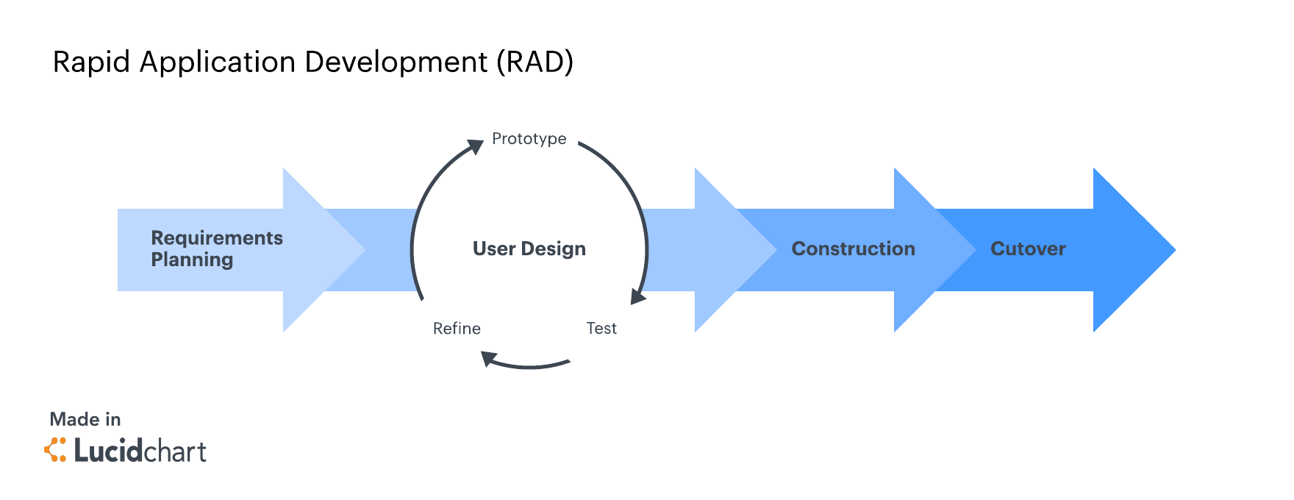Figure 6. Software Methodology of the System Using RAD
Requirement Planning
During this phase, the researchers will hold brainstorming sessions and discussions with students, faculty advisers and research critic to collect feedback and enhance the system requirements. They will employ task analysis and user scenarios to gain insights into how users are anticipated to engage with the employability prediction system. A detailed plan will be established to pinpoint the critical data needed for the study. This data will be gathered from the modified dataset found in Kaggle. Once all necessary data is collected, the researchers will process and refine it to ensure it is complete and accurate before using it to develop data-driven model and create career recommendations. A set of validated questionnaires from a recent study Research on the relationship between college students’ employability and IT skills training based on mixed research methods (Peng et al.,2022) will serve as the questionnaires for the employability test.
Table 2.1 presents the method of collecting data
Table 2.1 Data Collection Method
Factor | Data Type | Collection Instrument
Academic Records | Structured (GPA, grades, major) | Stack Overflow Records
Technical Skills | Structured (programming languages, tools, frameworks) | Stack Overflow Records
Soft Skills | Structured (communication, teamwork, professionalism) | Stack Overflow Records
Employment Data | Structured (employment status, job type, years of experience) | Stack Overflow Records
Certifications | Structured (type and count of certifications) | Stack Overflow Records
Demographics | Structured (age, gender, country, education level) | Stack Overflow Records

Table 2.2 presents the description of data features
Table 2.2 Dataset Features
Feature Name | Description | Data Type
Age | The age of the applicant:  >35 years old or <35 years old | Categorical
Gender | Gender identity of the respondent | Categorical
Major / Course | Degree program or specialization of the student | Categorical
EdLevel | Highest education level attained (Undergraduate, Master, PhD, etc.) | Categorical
GPA | Student’s academic performance score | Numeric
YearsCode | Total years of coding experience | Numeric
YearsCodePro | Years of professional coding experience | Numeric
HaveWorkedWith | Technologies or programming languages used | Text / Categorical
ComputerSkills | Number of technologies or tools known | Numeric
Professional Literacy | Self-evaluation of ethics, scientific spirit, and humanistic quality | Numeric
Technical Skills | Knowledge of computer operations, software design, and system innovation | Numeric
Soft Skills | Interpersonal, communication, and teamwork skills | Numeric
Cert_Count | Total number of certifications obtained | Numeric
Cert_Types | List or category of certification types (e.g., Cisco, CompTIA) | Categorical
Employment | Employment status indicator (1 = employed, 0 = unemployed) | Numeric (Binary)
Job_Type | Type of job or role (e.g., Developer, Designer, Manager) | Categorical

User Design
In this phase, the researchers will collect feedback from students and faculty advisers about the system's interface and functionality. The prototype for the employability prediction system will be created based on this feedback to make sure it meets user expectations and system goals. Furthermore, this phase includes reviewing and validating the data obtained from Kaggle. The attributes of the dataset will be identified, refined, and clearly defined to ensure they are appropriate for the employability clustering and association rule mining model.
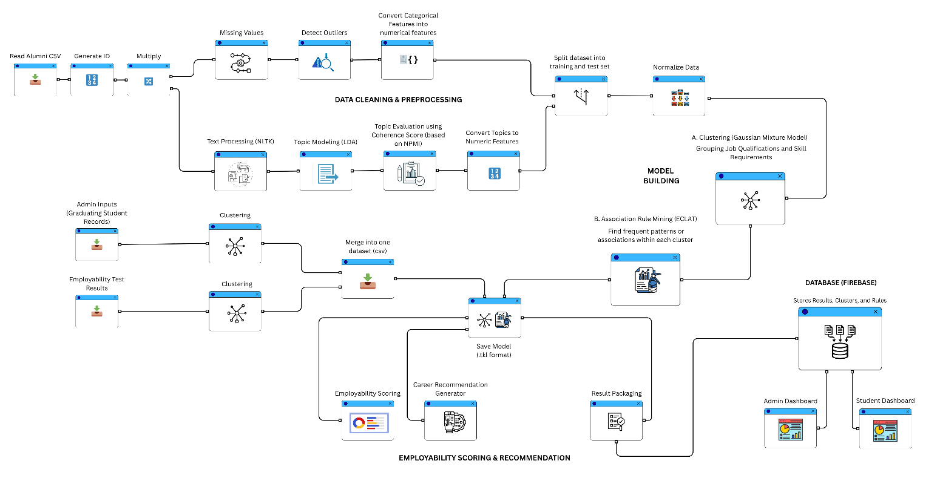

Figure 6.1 Block Definition Diagram of the system
The system utilizes two primary models—Gaussian Mixture Model (GMM) and ECLAT (Equivalence Class Clustering and bottom-up Lattice Traversal)—to assess and forecast employability outcomes. Initially, the GMM groups similar job qualifications and skill requirements by analyzing the modified dataset. This clustering helps identify key career areas such as software development, data analysis, or network administration, with each cluster representing a unique mix of skills and job attributes. This enables the system to evaluate how likely it is for a student to fit into a particular career group based on their employability test scores and profile information.
After clustering, the ECLAT algorithm is applied within each GMM cluster to discover common patterns and relationships between skills and qualifications. ECLAT identifies which skills frequently co-occur in employable profiles using metrics like support, confidence, and lift. The resulting association rules, along with the GMM clusters, are stored in a Firebase database, forming the foundation for employability scoring and career suggestions. When a new student record is processed, the system assigns the student to one or more GMM clusters and compares their skill set with the patterns derived from ECLAT to provide tailored career recommendations and an employability score.
Construction
During the construction phase, the researchers will develop the actual system and implement the predictive model. The system was coded using Python for the backend and machine learning components, React.js for the front-end interface, and Firebase as the database.
This phase included four major technical activities:
A.Dataset Collection
Information will be collected from a modified dataset found on Kaggle. This dataset includes detailed data about job applicants and their employability status.
The initial step of preprocessing will involve reviewing the modified dataset to identify any missing values, duplicates, or inconsistencies. Common problems like incomplete academic records, unreported skills, or incorrectly formatted categorical data will be addressed.
For numerical attributes with missing values, we will use mean or median imputation based on the data distribution's skewness. Since the Gaussian Mixture Model will assume that features follow a Gaussian-like distribution, numerical attributes will be normalized using Z-score standardization:​
Z = (X - μ) / σ
where $x_{i}$represents the raw feature value, $μ$is the mean, and $σ$ is the standard deviation. This transformation will ensure that all features contribute equally to the Euclidean distance computation within the GMM.
Categorical features (e.g., “Job_Type = Software Dev,” “EdLevel = Master”) will be encoded using One-Hot Encoding, resulting in binary indicator variables that are compatible with both GMM and ECLAT.
For the ECLAT algorithm, the dataset will be converted into a transaction-based vertical format, where each student is represented as a transaction $T_{i}$ containing a set of items (attributes).
Each attribute will be binary-coded as:
$$t_{ij}=\{\begin{matrix}1, & \text{if student }i\text{ has attribute }j \\ 0, & \text{otherwise}\end{matrix}$$
This representation will facilitate efficient computation of intersections between item sets to identify frequent patterns.
B. Model Building
As the name implies, a Gaussian mixture model involves the mixture (i.e. superposition) of multiple Gaussian distributions. Here rather than identifying clusters by “nearest” centroids, we fit a set of k gaussians to the data. And we estimate gaussian distribution parameters such as mean and variance for each cluster and weight of a cluster. After learning the parameters for each data point we can calculate the probabilities of it belonging to each of the clusters.
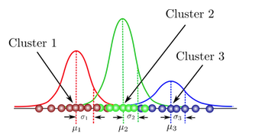
Figure 6.2 GMM visualization showing overlapping clusters
and Gaussian distributions
Every distribution is multiplied by a weight π(π1+π2+π3=1) to account for the fact that we do not have an equal number of samples from each category. Once the Gaussians overlap, a student can belong partly to multiple clusters, with probabilities (e.g., 70% tech-oriented, 30% data-driven).
Since the component assignments (cluster memberships) are unknown, the parameters of the GMM — namely the means $μ_{k}$, covariances $Σ_{k}$, and weights $π_{k}$— will be learned using the Expectation–Maximization (EM) algorithm.
- Initialization:
Randomly initialize $μ_{k},Σ_{k},π_{k}$for all clusters $k=1,…,K$.
- Expectation (E-step):
Compute the responsibility $γ_{ik}$, i.e., the probability that data point $x_{i}$belongs to cluster $k$:
$$γ_{ik}=\frac{π_{k}N(x_{i}∣μ_{k},Σ_{k})}{\sum_{j=1}^{K}{}π_{j}N(x_{i}∣μ_{j},Σ_{j})}$$
- Maximization (M-step):
Update the model parameters using the newly computed responsibilities:
$$N_{k}=\sum_{i=1}^{N}{}γ_{ik}$$$$μ_{k}=\frac{1}{N_{k}}\sum_{i=1}^{N}{}γ_{ik}x_{i}$$$$Σ_{k}=\frac{1}{N_{k}}\sum_{i=1}^{N}{}γ_{ik}(x_{i}−μ_{k})(x_{i}−μ_{k})^{⊤}$$$$π_{k}=\frac{N_{k}}{N}$$
- Convergence Check:
Evaluate the log-likelihood function:
$$ℒ=\sum_{i=1}^{N}{}log⁡(\sum_{k=1}^{K}{}π_{k}N(x_{i}∣μ_{k},Σ_{k}))$$
The process will repeat until the log-likelihood stabilizes or the change between iterations falls below a predefined threshold.
The expectation step corresponds to the latter case while the maximization step corresponds to the former. Thus, by alternating between which values are assumed fixed, or known, maximum likelihood estimates of the non-fixed values can be calculated efficiently.
Once EM finishes training the GMM for a given $K$, we will compute the Akaike Information Criterion (AIC) and Bayesian Information Criterion (BIC) to evaluate how well that model fits the data, while penalizing for complexity (too many clusters).
They are model selection criteria that balance:
- Goodness of fit (higher likelihood = better fit), and
- Model simplicity (fewer parameters = better generalization).
The AIC measures how well the model fits the data, while penalizing models that use too many parameters.
$$AIC=2p−2ln⁡(L)$$
where:
- $p$= number of parameters in the model
- $L$= maximized likelihood of the model
A lower AIC value indicates a better balance between fit and simplicity.
The BIC (also called the Schwarz criterion) is very similar, but applies a stronger penalty for model complexity — especially as the dataset grows.
$$BIC=pln⁡(N)−2ln⁡(L)$$
where:
- $N$= number of observations
- $p$= number of parameters
- $L$= maximized likelihood
The lower the BIC, the better the model. BIC is more conservative than AIC as it tends to favor simpler models, especially for large datasets.
This algorithm ensures that we reach a local optimal point, but it doesn't guarantee that this local optimum is the global one. Therefore, if the algorithm begins from various starting points, it typically results in different configurations.
In the employability prediction system, this probability allows the model to assign each student or job a degree of membership across multiple job-type clusters, enabling a more flexible and probabilistic classification rather than a single fixed assignment.
Cluster Quality Scoring and Cluster Weight Normalization
After GMM training is complete and K clusters have been identified, each cluster is assigned a quality score that reflects its overall employability strength. This score is computed as a weighted sum of the normalized feature centroids of the cluster:
quality_k = 0.30 × gwa_norm + 0.25 × survey_avg + 0.20 × tech_norm + 0.15 × soft_norm + 0.10 × cert_norm
where gwa_norm is the normalized academic score (inversely scaled from 1–5 GPA to [0,1]), survey_avg is the mean of the nine Likert-scale survey dimensions, tech_norm is the normalized technical skills count, soft_norm is the normalized soft skills average, and cert_norm is the normalized certification count. Clusters with higher quality scores represent stronger employability profiles and are labeled accordingly (Low / Moderate / High).
To convert cluster quality scores into a normalized probability distribution used for weighting, the Cluster Weight formula is applied:
w_k = (quality_k − min(quality) + ε) / Σ_j(quality_j − min(quality) + ε)
where quality_k is the composite score of cluster k, min(quality) is the smallest quality among all clusters, and epsilon (ε = 1e-6) is a small constant for numerical stability to avoid division by zero. The resulting weights sum to 1.0 and are used as multipliers in the Employability Score formula to scale each cluster’s contribution proportionally to its employability potential.
Once the GMM clusters are established, the ECLAT algorithm will be applied to uncover frequent co-occurrences of employability attributes within each cluster.
For each item (e.g., “Python Certified”), a Transaction ID set (TID-set) will be generated:
$$T(A)=\{t_{i}∣A∈t_{i}\}$$ECLAT then identifies frequent itemsets by intersecting TID-sets recursively:
$$T(A∪B)=T(A)∩T(B)$$
If the size of this intersection satisfies the minimum support threshold:
$$\text{support}(A∪B)=\frac{∣T(A∪B)∣}{N}≥\text{min_support}$$
then the combination is retained as a frequent pattern.
From these itemsets, association rules will be generated:
$$A⇒B$$
where the confidence and lift are defined as:
$$\text{confidence}(A⇒B)=\frac{\text{support}(A∪B)}{\text{support}(A)}$$$$\text{lift}(A⇒B)=\frac{\text{support}(A∪B)}{\text{support}(A)×\text{support}(B)}$$
Rules with lift > 1 will indicate meaningful relationships between attributes and job outcomes.
After both models are trained, the system will integrate their outputs to compute the Employability Score (ES) and Job Score (JS).
For a given student $i$, the Employability Score will be calculated as a weighted sum of GMM cluster probabilities and ECLAT rule confidences:
$$ES_{i}=α\sum_{k=1}^{K}{}γ_{ik}w_{k}+(1−α)\sum_{r=1}^{R}{}c_{r}l_{r}$$where:
- $γ_{ik}$is the GMM responsibility of cluster $k$for student $i$,
- $w_{k}$is the cluster’s weight (related to its employability strength),
- $c_{r}$and $l_{r}$are the confidence and lift of the $r^{th}$ECLAT rule satisfied by the student,
- $α$(0 ≤ α ≤ 1) controls the contribution of the two models.
Displayed Employability Score
In addition to the ES fusion formula above, the system also computes a normalized Displayed Employability Score to provide students with a straightforward percentage-based indicator of their overall readiness. Each dimension is first normalized to the range [0, 1]: academic = (5.0 − GWA) / 4.0 (inverse scale since lower GWA is better in the 1–5 system), survey = survey_avg / 5.0, skills = tech_skills_count / 40.0, soft = soft_skills_avg / 5.0, cert = cert_count / 5.0. The displayed score is then computed as:
score = (0.30 × academic + 0.25 × survey + 0.20 × skills + 0.15 × soft + 0.10 × cert) × 100
This score provides a human-readable, interpretable measure of student employability ranging from 0 to 100, and is displayed on the student dashboard alongside the GMM-ECLAT fusion score. It serves as the primary student-facing indicator while the fusion ES score drives the internal clustering and recommendation engine.
Similarly, each job $j$will have a Job Score (JS) computed based on how strongly its requirements align with the same clusters and association rules:
$$JS_{j}=β\sum_{k=1}^{K}{}p_{jk}w_{k}+(1−β)\sum_{r=1}^{R}{}c_{r}l_{r}$$
Matching between students and jobs will then be performed by maximizing the cosine similarity between $ES_{i}$and $JS_{j}$:
$$\text{Match}(i,j)=\frac{ES_{i}⋅JS_{j}}{∥ES_{i}∥∥JS_{j}∥}$$
This will produce probabilistic, interpretable, and explainable employability recommendations.
By integrating GMM’s probabilistic clustering with ECLAT’s effective frequent-pattern mining, the system effectively combines unsupervised grouping of students and jobs with the identification of attribute-outcome associations, which helps in providing tailored employability and career recommendations.
C. Model Validation
Once the model is built, it will be thoroughly validated through K-Fold Cross-Validation. The performance will be assessed using Accuracy, Precision, Recall, F1-Score, AUC-ROC for probabilistic assessment, RMSE for evaluating continuous employability scores, and Stability Index to check consistency across the folds.
D.Model Deployment
The validated model will be incorporated into a web-based employability prediction system, acting as the main analytical engine for providing real-time predictions. The backend API will link the model's results to the user interface, ensuring smooth data transfer between the system's processing layer and the front-end dashboard. After students fill out the employability questionnaire, their responses will be automatically processed using the trained Gaussian Mixture Model (GMM) and ECLAT algorithm, allowing them to see their results right away. The system will generate each student’s employability score, relevant career cluster, and tailored career suggestions based on their profile and the identified association rules. This integration will create an interactive, data-driven experience where students can quickly grasp their employability status and explore appropriate career options highlighted by the model.
Cutover
This phase emphasizes putting the final system into action and delivering it to the users. Deployment and training for users take place at the Department of Computer Studies. Key activities in this phase include hosting the web application on either a local or online server, testing the system with a group of students, faculty, and administrators, conducting training sessions for users, and gathering feedback for enhancements. The researchers also make adjustments to the system based on the evaluation results to ensure it functions well and meets user needs. Once final testing is complete, the system is officially launched for research evaluation in accordance with ISO/IEC 25010 Software and Data Quality standards.
System Testing
During the testing phase, the researchers will conduct a series of tests to ensure the accuracy, stability, and usability of the Employability Prediction System. The testing phase aimed to verify that all system modules and predictive components functioned according to the intended design and objectives of the study.
The following testing procedures were performed:
- Unit Testing
Each module of the system will individually be tested to ensure proper operation. This included testing the employability test form, database connections, model integration scripts, and output display components. The researchers verified that every function executed correctly without producing errors.
- Integration Testing
Integration testing will be conducted to ensure that the modules worked together seamlessly. The backend (Python-based model), database (Firebase), and frontend interface (React.js) were tested for consistent data flow. The researchers confirmed that user responses were correctly stored, processed by the model, and displayed as results on the interface.
- Model Testing
The predictive model will be thoroughly assessed to verify the reliability of employability clustering and the validity of the association patterns it produces. Initially, the Gaussian Mixture Model (GMM) will be refined through an iterative Expectation-Maximization (EM) process. After this, model selection will be conducted using the Bayesian Information Criterion (BIC) and Akaike Information Criterion (AIC) to identify the best number of clusters, denoted as 𝐾. These criteria will help balance the model's fit and complexity by penalizing overly complex models, ensuring that the final clustering structure is both simple and statistically robust.
Once the optimal GMM setup is determined, cross-validation will be performed using negative log-likelihood scoring to evaluate the model's consistency, generalizability, and the quality of separation across various data subsets. This step will confirm that the cluster assignments remain stable and meaningful when applied to new data.
Silhouette Score
In addition to negative log-likelihood cross-validation, the Silhouette Score is computed to assess the quality of cluster separation without relying on ground-truth labels. For each sample i, a(i) is the mean intra-cluster distance (average distance to all other points in the same cluster) and b(i) is the mean nearest-cluster distance (average distance to all points in the next closest cluster). The overall score is the mean across all samples:
Silhouette Score = mean_i[ (b(i) − a(i)) / max(a(i), b(i)) ]
A Silhouette Score close to 1.0 indicates that samples are well-separated and cohesive within their assigned cluster; a value near 0.0 means samples lie near cluster boundaries; and a negative value indicates potential misassignment. The Silhouette Score is only computed when the number of training samples exceeds the number of GMM components K, and is reported alongside AIC and BIC in the model’s training diagnostics.
Following this, the ECLAT algorithm will be validated by calculating Support, Confidence, and Lift metrics to assess the strength, frequency, and statistical significance of the identified association rules. Rules with a lift greater than one will be regarded as significant and indicative of genuine relationships between student characteristics and employability outcomes. Overall, these evaluation steps will ensure that the proposed system generates consistent, interpretable, and statistically valid employability groupings based on the modified data.
5. User Acceptance Testing (UAT)
User acceptance testing will be conducted with a sample group of Computer Studies students and faculty members. Participants were asked to use the system and provide feedback regarding usability, interface design, and accuracy of employability results.
The responses will be evaluated to determine user satisfaction and the practicality of the system for academic and career guidance purposes.

6. Performance Testing

Performance testing measured the system’s response time and efficiency under normal and peak loads. The system was tested to ensure that multiple users could take the employability test simultaneously without delays or crashes.

System Evaluation
The system will be evaluated using the modified ISO/IEC 25010 Software and Data Quality Evaluation Instrument. The evaluation focused on functionality, suitability, performance efficiency, compatibility, interaction capability, reliability, security, maintainability, flexibility, and safety as shown and n Table 3.

Table 3. Software and data quality evaluation instrument
INDICATOR | 5 |  | 4 |  | 3 |  | 2 |  | 1
A. Functional Suitability
- Functional completeness - degree to which the set of functions covers all the specified tasks and intended users' objectives.
- Functional correctness - degree to which a product or system provides accurate results when used by intended users.
- Functional appropriateness - degree to which the functions facilitate the accomplishment of specified tasks and objectives.
B. Performance Efficiency
- Time behaviour - degree to which the response time and throughput rates of a product or system, when performing its functions, meet requirements.
- Resource utilization - degree to which the amounts and types of resources used by a product or system, when performing its functions, meet requirements.
- Capacity - degree to which the maximum limits of a product or system parameter meet requirements.
C. Compatibility
- Co-existence - degree to which a product can perform its required functions efficiently while sharing a common environment and resources with other products, without detrimental impact on any other product.
- Interoperability - degree to which a system, product or component can exchange information with other products and mutually use the information that has been exchanged.
D. Interaction Capability
- Appropriateness recognizability - degree to which users can recognize whether a product or system is appropriate for their needs.
- Learnability - degree to which the functions of a product or system can be learnt to be used by specified users within a specified amount of time.
- Operability - degree to which a product or system has attributes that make it easy to operate and control.
- User error protection - degree to which a system prevents users against operation errors.
- User engagement - degree to which a user interface presents functions and information in an inviting and motivating manner encouraging continued interaction.
- Inclusivity - degree to which a product or system can be used by people of various backgrounds (such as people of various ages, abilities, cultures, ethnicities, languages, genders, economic situations, etc.).
- User assistance - degree to which a product can be used by people with the widest range of characteristics and capabilities to achieve specified goals in a specified context of use.
- Self-descriptiveness - degree to which a product presents appropriate information, where needed by the user, to make its capabilities and use immediately obvious to the user without excessive interactions with a product or other resources (such as user documentation, help desks or other users).
E. Reliability
- Faultlessness - degree to which a system, product or component performs specified functions without fault under normal operation.
- Availability - degree to which a system, product or component is operational and accessible when required for use.
- Fault tolerance - Degree to which a system, product or component operates as intended despite the presence of hardware or software faults.
- Recoverability - degree to which, in the event of an interruption or a failure, a product or system can recover the data directly affected and re-establish the desired state of the system.
F. Security
- Confidentiality - degree to which a product or system ensures that data are accessible only to those authorized to have access.
- Integrity - degree to which a system, product or component ensures that the state of its system and data are protected from unauthorized modification or deletion either by malicious action or computer error.
- Non-repudiation - degree to which actions or events can be proven to have taken place so that the events or actions cannot be repudiated later.
- Accountability - degree to which the actions of an entity can be traced uniquely to the entity.
- Authenticity - degree to which the identity of a subject or resource can be proved to be the one claimed.
- Resistance - degree to which the product or system sustains operations while under attack from a malicious actor.
G. Maintainability
- Modularity - degree to which a system or computer program is composed of discrete components such that a change to one component has minimal impact on other components.
- Reusability - degree to which a product can be used as an asset in more than one system, or in building other assets.
- Analyzability - degree of effectiveness and efficiency with which it is possible to assess the impact on a product or system of an intended change to one or more of its parts, to diagnose a product for deficiencies or causes of failures, or to identify parts to be modified.
- Modifiability - degree to which a product or system can be effectively and efficiently modified without introducing defects or degrading existing product quality.
- Testability - degree of effectiveness and efficiency with which test criteria can be established for a system, product or component and tests can be performed to determine whether those criteria have been met.
H. Flexibility
- Adaptability - degree to which a product or system can effectively and efficiently be adapted for or transferred to different hardware, software or other operational or usage environments.
- Scalability - degree to which a product can handle growing or shrinking workloads or to adapt its capacity to handle variability.
- Installability - degree of effectiveness and efficiency with which a product or system can be successfully installed and/or uninstalled in a specified environment.
- Replaceability - degree to which a product can replace another specified software product for the same purpose in the same environment.
- Safety
- Operational constraint - degree to which a product or system constrains its operation to within safe parameters or states when encountering operational hazard.
- Risk identification - degree to which a product can identify a course of events or operations that can expose life, property or environment to unacceptable risk.
- Fail safe - degree to which a product can automatically place itself in a safe operating mode, or to revert to a safe condition in the event of a failure.
- Hazard warning - degree to which a product or system provides warnings of unacceptable risks to operations or internal controls so that they can react in sufficient time to sustain safe operations.
- Safe integration - degree to which a product can maintain safety during and after integration with one or more components.

Data analysis plan. For the data analysis of data, Table 4 shows the descriptive interpretation of the mean.
Table 4. Descriptive interpretation of the mean
NUMERICAL SCALE | DESCRIPTIVE INTERPRETATION
4.51 – 5.00 | Excellent
3.51 – 4.50 | Very Good
2.51 – 3.50 | Good
1.51 – 2.50 | Fair
1.50 – below | Poor

Implementation Plan
Table 5 shows the implementation plan of the system
Table 5. Implementation plan
STRATEGY | ACTIVITIES | PERSONS INVOLVED | DURATION
Project Approval | Preparation and submission of request letter for implementation approval from the Department of Computer Studies. | Researchers, Department Head | 1 day
System Setup and Installation | Installation of required software (Python, Firebase, React.js) and deployment of the Employability Prediction System on local or institutional servers. | Researchers | 1 Day
Data Gathering | Modified dataset from Kaggle | Researchers | 4-5 Weeks
System Implementation and Testing | Full deployment of the system, testing its usability and accuracy with actual data from respondents. | Researchers, Selected Users | 1 Week
Feedback Collection and Refinement | Collection of feedback from users for system improvement and minor adjustments. | Researchers, Faculty Evaluators | 3 days
Final Evaluation and Documentation | Compilation of evaluation results, system performance reports, and preparation for final defense presentation. | Researchers, Research Adviser, Research Critic | 1 Week

